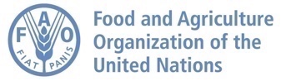


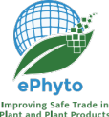

IPPC Generic ePhyto National System (GeNS)

Onboarding Document

Public – IPPC/FAO
Contents
1 Introduction 3
2 GeNS Customization 3
3 NPPO Information 3
3.1 NPPO Information 3
3.2 NPPO Offices 5
3.3 NPPO Users 5
3.4 Exporters and Consignees 6
3.5 Commodity Search Language 6
4 Technical Requirements 8
4.1 Overview 8

Introduction
The Generic ePhyto National System (GeNS) – is capable of sending and receiving ePhytos as well as producing paper phytosanitary certificates (PC). The GeNS is expected to be used by countries without a national electronic phytosanitary system. Secure access to the GeNS will be provided to the NPPO, who will manage access for their government and industry users. The information gathered in this document will help customize the GeNS for requesting NPPO.

GeNS Customization
Generic National System (GeNS) customization is the process of tailoring the GeNS application for each NPPO. The purpose of this document is to provide a means to communicate NPPO information required for the GeNS application customization.

NPPO Information
In this section, the NPPO specifies details for the NPPO country and NPPO users.

Country Name: Enter your official Country name

Point of Contact Name: Enter the point of contact for this survey
Point of Contact Title: Enter the title of the point of contact
NPPO Name: Enter the official NPPO Name
Email: Enter the point of contact email
Phone number: Enter the phone number of the point of contact

For questions contact:
Click here to enter text.
Click here to enter text.

NPPO Information
1. | NPPO PC Information | How many PCs are received per year?
1. | NPPO PC Information | How many PCs are issued per year?
2. | NPPO port/office type where PCs are issued | How many seaports will issue PCs?
2. | NPPO port/office type where PCs are issued | How many airports will issue PCs?
2. | NPPO port/office type where PCs are issued | What other locations will issue PCs? (District office, headquarters, etc.)
2. | NPPO port/office type where PCs are issued | Other locations?
3. | Government/Department Logo |   Please provide a government logo or text.  Specification: PNG Format; size 340px x 70px; resolution 72
4. | National Flag | Please provide a link to or an image of the national flag. The image will be used to verify the correct flag to display in the login page.  Specification: PNG Format; size 197px x 31px; resolution 72
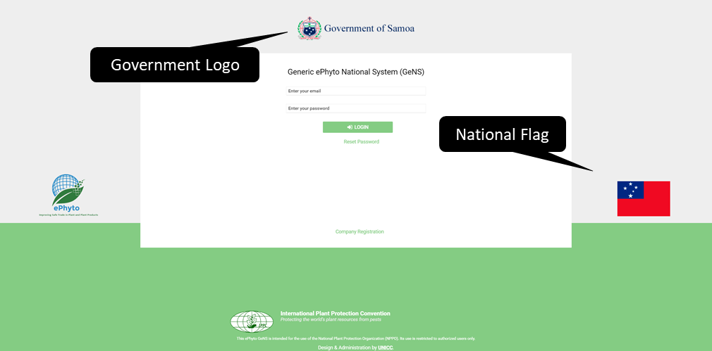
Figure 1 – Example: Government or Department Logo and National Flag position on login page
5. | Agency/NPPO Name | Please provide the official NPPO name
6. | Government/Departmental Name | Please provide the department name (e.g. Department of Agriculture, Ministry of Agriculture and Fisheries, etc.)
7. | Agency/NPPO Logo | The image will be used in the GeNS export Phyto PDF  Specification: PNG Format; size 340px x 70px; resolution 72
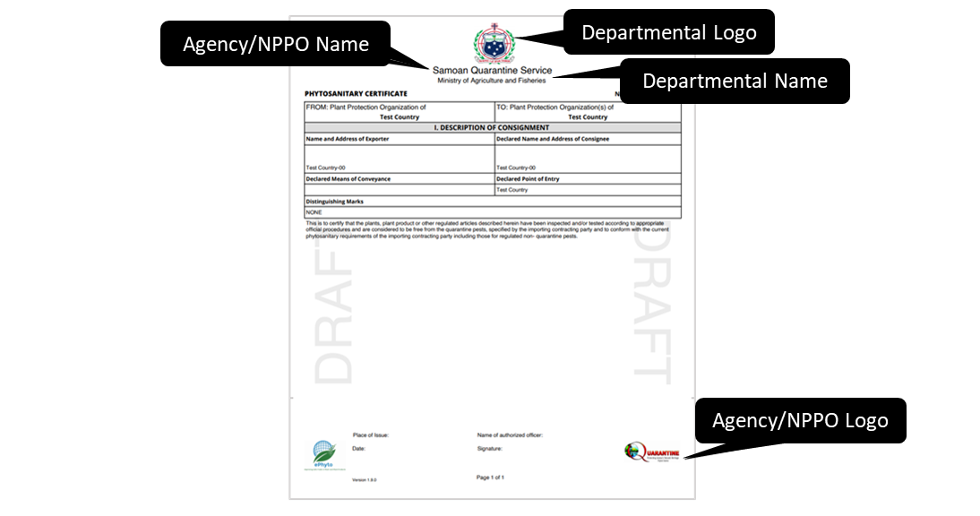
Figure 2 – Example: Departmental Logo, Agency/NPPO Name, Departmental Name and Agency/NPPO Logo on the GeNS export Phyto PDF

NPPO Offices
Please provide a list of office locations/office names to be included in the GeNS
Office Location | Office Name

NPPO Users
Please provide information on NPPO users (NPPO Administrator, NPPO Officer, NPPO Inspector and NPPO Assistant) that will use the GeNS.
6. | What is the total number of staff in the NPPO that will use the GeNS?
7. | Please specify how many users you wish to appoint as Primary NPPO Administrator/s.  Please note that all NPPO Administrators can enable/disable other admin accounts, however only the Primary NPPO Admin/s will be able to completely remove such role from other users. This configuration can also be modified at later stage.
Note: In case of large number of users who need access from the NPPO, we can assist in uploading all the users at one time instead of individually creating them by providing a list in the following format (if possible with a CVS file).
Name | Surname | Office/Port Name | Email | Roles | Primary NPPO Admin
Lana | Luca | Port Medan | l.lana@xyz.org | NPPO Administrator | Yes
Sam | Brooks | Port Medan | s.brooks@xyz.org | NPPO Administrator | No
John | Smith | Port Bali | j.smith@xyx.org | NPPO Officer | n/a
John | Doe | Port Jakarta | j.doe@xyx.org | NPPO Inspector | n/a
Bret | Lee | Port Surabaya | b.lee@xyx.org | NPPO Assistant | n/a
* Examples are marked in grey italics. Please delete these entries and enter the current information that is relevant to your NPPO

Exporters and Consignees
Please provide a list of Exporters and Consignees to be included in the GeNS
Exporters:
Alias* | Exporter Name | Office Name | Contact email* | Contact Phone | Address* | City | Zip Code (if any)
Jakarta Grain Company - West | Max  Malian | Indochine | max@xyz.org | 123456789 | Cikutra  No. 165 | Jakarta | 511243
*Examples are marked in grey italics. Please delete these entries and enter the current information that is relevant to your NPPO
Consignees:
Alias* | Consignee Name | Office Name | Contact email | Contact Phone | Address* | City | Zip Code (if any) | Country*
Malaysia Grain Company Inc. | Milu Aja | Jaka | mil@xyz.org | 222222 | Labuan  bajo 18 | Kuala Lumpur | 12345 | Malaysia
*Examples are marked in grey italics. Please delete these entries and enter the current information that is relevant to your NPPO

Commodity Search Language
You can restrict your search for common names to a given language.
If you wish to enable some languages in your search result, select the appropriate language box. Please note that, the NPPO Administrator will be able to edit this configuration at later stage if needed.
Languages | Enable | Languages | Enable | Languages | Enable | Languages | Enable
af - Afrikaans |  | eu - Basque |  | lt - Lithuanian |  | ru - Russian
ak - Akan |  | fi - Finnish |  | lv - Latvian |  | sk - Slovak
ar - Arabic |  | fr - French | ✓ | mo - Moldavian |  | sl - Slovene
ba - Bashkir |  | gl - Galician |  | ms - Malay |  | sn - Shona
be - Belarusian |  | gn - Guarani |  | mt - Maltese |  | sq - Albanian
bg - Bulgarian |  | he - Hebrew |  | na - Nauru |  | sr - Serbian
ca - Catalan |  | hr - Croatian |  | nb - Norwegian bokmål |  | sv - Swedish
cs - Czech |  | hu - Hungarian |  | nl - Dutch |  | sw - Swahili
da - Danish |  | is - Icelandic |  | no - Norwegian |  | th - Thai
de - German |  | it - Italian |  | oj - Ojibwa |  | tr - Turkish
el - Greek |  | ja - Japanese |  | pl - Polish |  | uk - Ukrainian
en - English | ✓ | ka - Georgian |  | pt - Portuguese |  | yi - Yiddish
es - Spanish | ✓ | ko - Korean |  | rm - Romansh |  | zh - Chinese
et - Estonian |  | la - scientific | ✓ | ro - Romanian |  | zu - Zulu

Any other information that the NPPO would like to provide:

Technical Requirements

Overview
The GeNS is an IT system based on ‘web-technology’; the users of the system do not need any specific IT setup on their computers as long as they have access to the internet using one of the main web browsers. Below is a list of minimal requirements.
The GeNS does not require specific hardware requirements, below the supported operative systems and browsers combination.

Desktop
OS / Browsers | Windows 10 | Windows 11 | macOS | Apple M1 | Apple M2 | Linux (20 & 22 +)
Chrome | • | • | • | • | • | •
Firefox | • | • | • | • | • | •
Edge | • | • | • | • | • | -
IE | 11 | - | - | - | - | -
Safari | - | - | • | • | • | -
Opera | • | • | • | • | • | •
• The last 3 major versions released as of May 2024.
TABLETS iOS, Android, Win Phone
Android 10+ (10, 11, 12, 13) | Chrome | Edge | Firefox
iOS 14+ (14, 15, 16) | Safari | - | -
Windows 10+ (10, 11) | Chrome | Edge | Firefox

Any tablet would work, with a minimum 750px of width and 540px of height (using screen orientation as required).
Mobile devices are not supported.
Internet: a stable connection to the internet, the GeNS exchanges with the backend services small packets and does not require a large bandwidth; mobile/SIM connections can be used effectively.
Printer: Any printer that supports A4 for the optional printing of the certificate would work.
Scanner: could be needed to scan received paper certificates (ie re-export attachment of the original certificate)
Software: it is recommended to have a PDF reader (the printable copy of the certificate and other reports are generated in PDF), and also a compatible Office Excel to utilize the offline commodity upload functionalities.

